# **Format for uploading details in GitHub and Slack in word file format**

**Student Name: Shrinivasa**

**Class and Sec: VI B**

**USN: 4AL17CS092**

|  |  |  |  |  |
| --- | --- | --- | --- | --- |
| **Online Test Details** | | | | |
| **Subject** | **PAP Assignment-4, Java** | | | |
| **Semester** | **VI - B** | | **Duration** | **30 Minutes, 30 Minutes** |
| **85%, 90%** | | **17/20, 9/10** | | |

**Encl: snapshot of the test result**

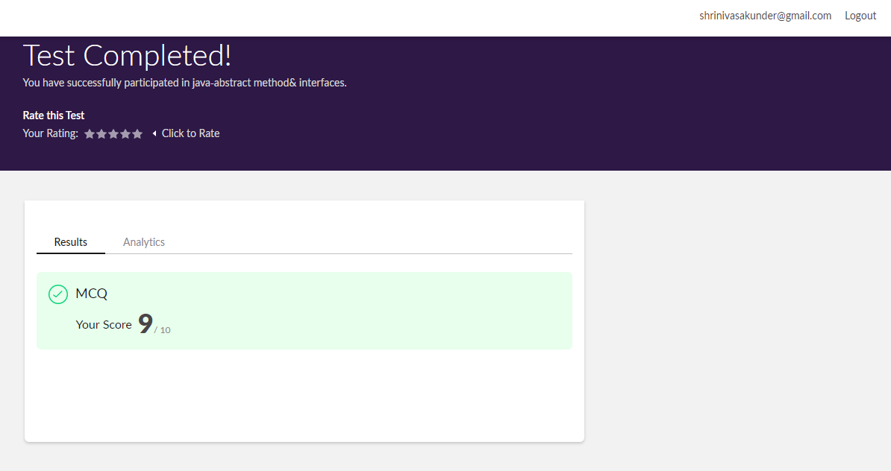

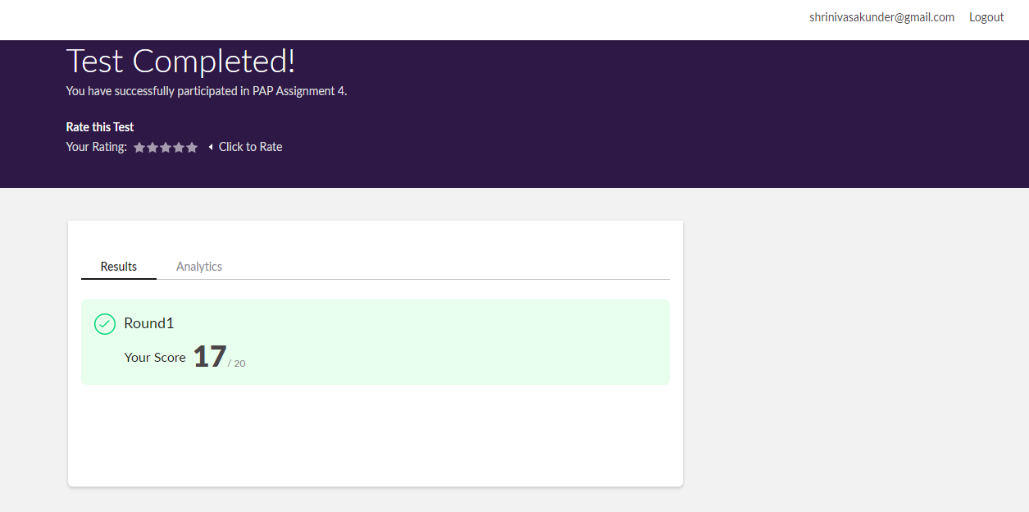

|  |  |  |  |
| --- | --- | --- | --- |
| **Pre-Placement Training Summary** | | | |
| **Pre placement training** | **9:00 am to 11:00 am - Programming in Java**  **11:00 am to 1:00pm - Programming in C** | | |
| **Faculty** | **Ms. Sharan Pais**  **Mrs. Merlyn mathias** | **Duration** | **4 hours** |

**Encl: snapshots of the daily class activities (at least two snap shot)**

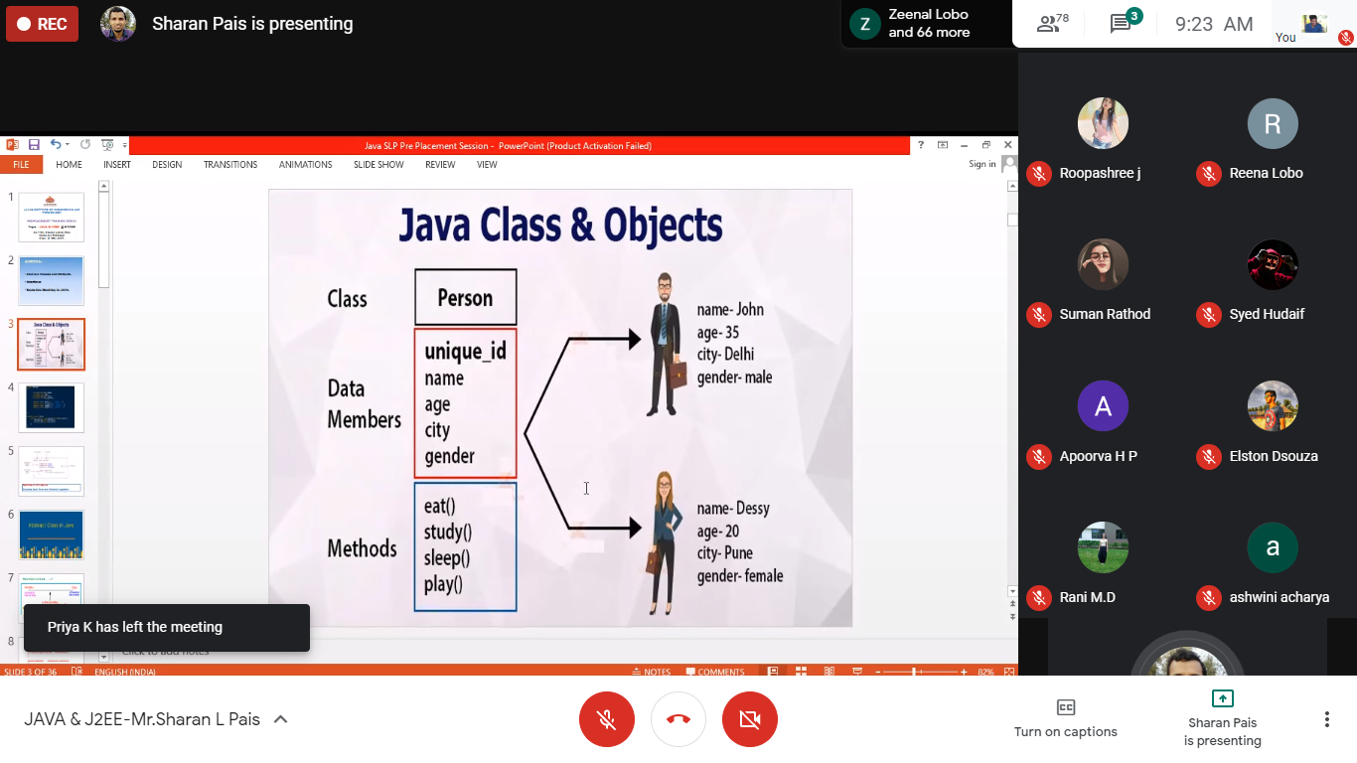

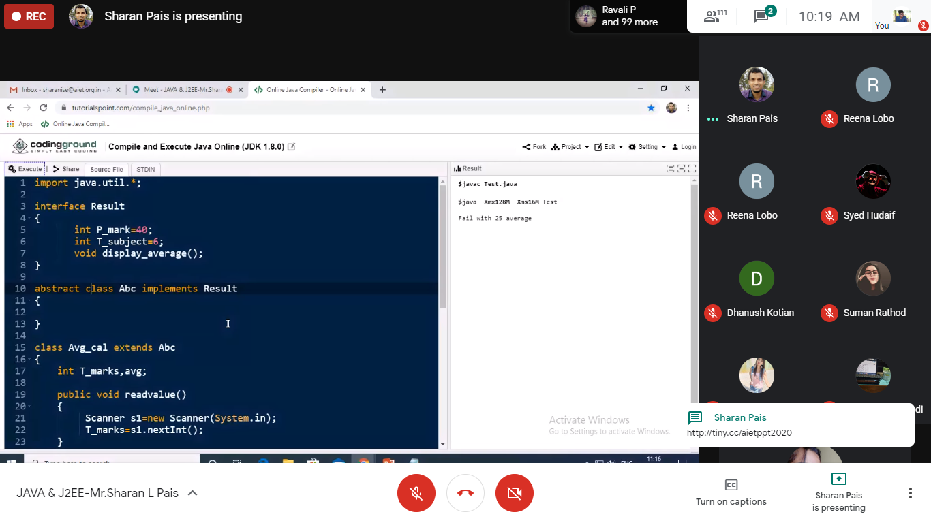

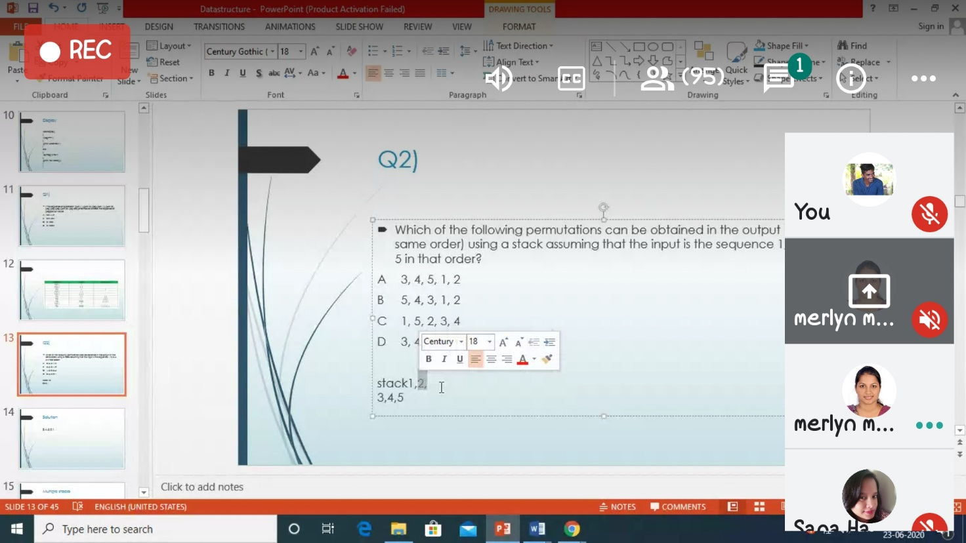

|  |  |
| --- | --- |
| **Coding Challenges** | |
| **Problem Statement: Pro1(c)**  [**https://github.com/Shrinivasakunder/certification-and-online-coding**](https://github.com/Shrinivasakunder/certification-and-online-coding) | |
| **Status: Completed** | |
| **Uploaded the report both in GitHub & Slack** | **Yes** |

**Encl: snapshots of your response to challenge.**

**Pro1(c):**

**Write a C Program to Sort a stack using a temporary stack.\**

#include<stdio.h>

void main()

{

int a[20],n,top1=0;

printf("Enter The Number Of Elements:\n");

scanf("%d",&n);

printf("Enter The Elements Into Stack:\n");

while(top1<n)

{

scanf("%d",&a[top1++]);

}

int b[20],top2=-1,t;

while(top1>0)

{

t=a[--top1];

while(top2>=0 && b[top2]>t)

{

a[top1++]=b[top2--];

}

b[++top2]=t;

}

int i=0;

printf("Stack After Sorting:\n");

while(i<=top2)

{

printf("%d\n",b[i++]);

}

}

**Output:** 